Newsletter – February 2018
Happy Valentine’s Day!
Hello all Glassy Folks,
We are having a Pre-Valentine’s SALE! Less 20% on all our finished jewellery and glass beads from today until 14/2/2018! (excluding consignment stock)
And that’s not all! LESS 10% on all Effetre glass rods from today until 14/2/2018!
Good News: We received a new shipment of glass from Murano, Italy recently. This means all our standard basic colours are back in stock again – like White, Black, the Reds, Greens, Turquoise and we also received a nice batch of Light Pink Pastel!
Here you can see our Sarah and Tienie unpacking the glass and finding space for the bundles. Each bundle weighs 10Kg and is 1 metre in length! It is Tienie’s job to cut the rods in shorter lengths for use at the torch. It is also more practical for local mail orders to courier shorter rods.
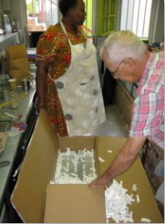
If you didn’t know - you heard right! We still do Mail Orders! We courier glass rods etc. right to your door, Overnight, to anywhere in South Africa! We also supply our Overborder lampworker customers who have to wait a little bit longer than Overnight.
We are Thankful to each and every Lampworker for their support and who gets their glass rods from us. Without you, we would not have been here!
Let us continue to grow Lampwork in South Africa, by spreading awareness about this ancient craft and art-form and by supporting each other! Local is sometimes still Lekker !!!
Another great bonus is that we now have stock of Bella Murano Sandra Schenck’s wonderful Rose Murrine for sale! (if you have No idea what the heck I’m talking about, here are some beads I’ve made with Sandra’s roses.
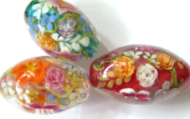 Visit our Facebook page if you want to see more bead pictures: https://web.facebook.com/Glass-and-Fire-156848201006776/

For those interested in learning to make glass beads - we still do our 2-day Beginners class in glass bead making. Intermediate and Advanced techniques are done on request, talk to us if you want to expand your glass bead making skills.
If you have any special bead requirements, Sarah and Johan will be happy to fulfil your order! We are mostly busy during the day with making beads and would love to make beads for you according to your taste.
We are also happy to re-string your old or broken jewellery at a minimal fee!
So, fellow Lampworkers and Glass & Fire friends, until next time!
And remember to have FUN!
Johan, Tienie and Sarah

